Transport and Planning Issues in Western Australia
A CUSP Discussion Paper for the 2021 State Election
By
Peter Newman AO
Professor of Sustainability
Curtin University

Introduction
There are only three issues in the 2021 WA election: Covid, Covid and Covid. But I will still try to suggest a few ideas on transport and planning as I have done ever since 1983. That was the year I helped the Friends of the Railways win back the Fremantle Railway and began a journey that continues to this day, to expand the role of railways in WA. So I will start with MetroNet and then the potential to rebuild country rail but will also suggest a few things about new technology that will shape our future state: Trackless Trams, new port technology to help with Westport and with regional ports based on Hydrogen, the electromobility transition and how we can make the most of this inevitable move into cars, buses, bikes, scooters and small planes, and finally the global move to Net Zero Everything which I would suggest needs to include Net Zero Urban Development and Net Zero Transport.

Transport and planning are always a mixture of the long-term perspectives that lead to short-term small steps and I will therefore be suggesting what needs to be the Long-Term Vision and the Short-Term Steps.

MetroNet – the Context and Future
MetroNet is the historical infrastructure we are fortunate to be seeing built in our lifetime in Perth. The seven new rail lines and the Metro Hubs associated with its stations will be a long-term game-changer in Perth, it will last for generations. In the 80’s as the rail rebuilding began we always wanted to see a visionary rail system to go with a rebuilding of the three older lines and dreamed of the northern line and the southern line, but it was hard to see how rapidly we have moved to an extra 72km of rail and 18 new stations. We have moved from 7 million passengers a year when the Fremantle Line was re-opened to 70 million a year now. This should at least double and continue rising as it has considerable capacity for expansion whereas the road network does not, indeed freeway capacity increases are reaching their limits now.

There are three extra steps needed: extending fast trains to regional centres; connecting across the corridors with mid-tier Trackless Trams; and completing the inner circle line. The first two are covered in the next two sections and here I will focus on completing the proposed MetroNet.

The original map of MetroNet that went to the last election is below. It contains two inner circle rail lines.

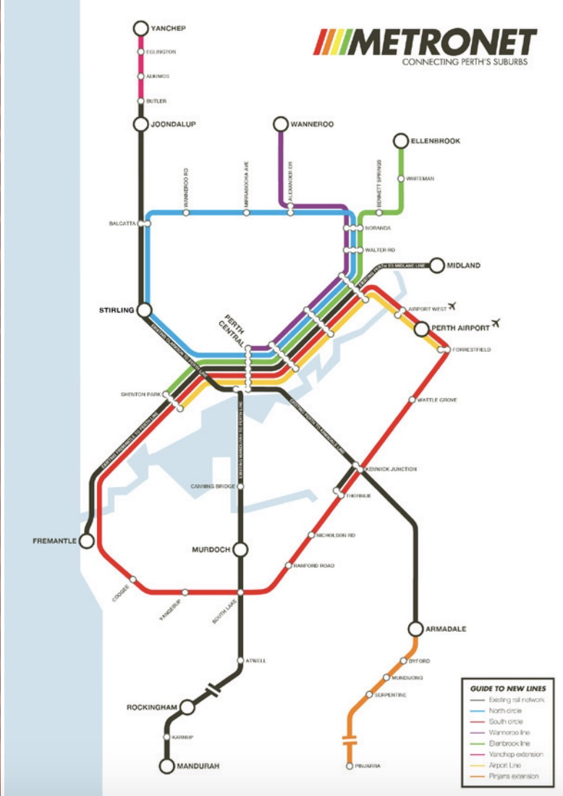
Figure 1. Original MetroNet map in 2016 election.

Somewhere in the last few years of detailed work this map has changed. The circle line in the south continued the Thornlie line along the freight line but now it stops at Cockburn Central. This part of the Circle Rail is being built and will be a successful addition to the system but so will the section that continues through to Fremantle and is arguably far more important in the next decade after Westport is built. Cockburn Central to Fremantle will mean that the southern corridor can regain its connection to Fremantle as well as to the western suburbs including educational and health facilities. There are many economic and social advantages in enabling people from the southern corridor to change at Cockburn Central or to have some trains that split there with some going to Fremantle then Perth, and some going to Thornlie and then Perth. The southern suburbs could then have stations at Spearwood, Coogee and South Beach which are growing densely.

The value of Circle Rail systems has been recognised in recent years (Sydney and Melbourne are building them) and have been analysed for their economic advantages by Michael Kane. The fundamental idea is that large productivity gains occur when a city has a mega-central area, not just a CBD based on radial rail lines and sub-centres along them. The mega-central area in Perth would be the area within the two Circle Rail Lines and the globally-oriented knowledge economy jobs will automatically spread around within those areas. Regional rail lines can feed into these rail lines and easily move around between them with most major services in those areas – see below on country rail. The sub centres further out of the city will still have major functions but will be more like local centres than being part of the global economy that Perth will increasingly relate to, especially in the era of battery minerals and the solar-based Hydrogen processing of minerals – see below under Regional Development.

The obvious issue with continuing the Circle Rail to Fremantle is that the freight line is very narrow in Fremantle. This then links with the need to move the container terminal to Westport as quickly as possible and would enable both the regeneration of North Fremantle and the regeneration of major stations along the line to the south of Fremantle along the rail line (South Beach, Coogee and Spearwood) all of which are underway.

Other elements of the Circle Lines in the south and in the north should not be lost as in the long term they will be needed. There is a powerful logic to this older version of MetroNet for the long-term future of Perth.

Short-Term:
1. Complete the MetroNet vision that has begun to give Perth 7 new rail lines.
2. Develop a detailed version of the Cockburn Central to Fremantle passenger rail line as soon as a decision is made on when the container functions at Fremantle are moved to Westport (within the next term of government).
3. Complete the link to Fremantle from Cockburn Central within the 2020’s.

Long-Term:
1.Re-examine the strategic value of the Circle Rail links in the original MetroNet map for the rest of the Southern Ring as well as the Northern Ring and ensure their core planning is not undermined in the short term by road projects.

Fast Train to Bunbury – First Step in Rebuilding Country Rail and Country Towns
The announcement of a business case for a fast train to Bunbury is very welcome. The Australind can keep going as a slow train along the edge of the scarp linking historic farming towns but the coastal strip needs a modern fast train going eventually to Busselton and up to Geraldton. Fast electric trains have enabled cities to link their rural hinterlands in productive ways, especially to help with tourism which is essentially best when its not car-dependent. This means there needs to be an integrated linkage of tourist services at stations that can enhance the local economy and enable people who live in regions to make the fast train link to Perth easier to access. We have been doing a detailed study of how an iconic Trackless Tram tourist route between Bunbury and Busselton would work well. See photo below and more on Trackless Trams in the next section.

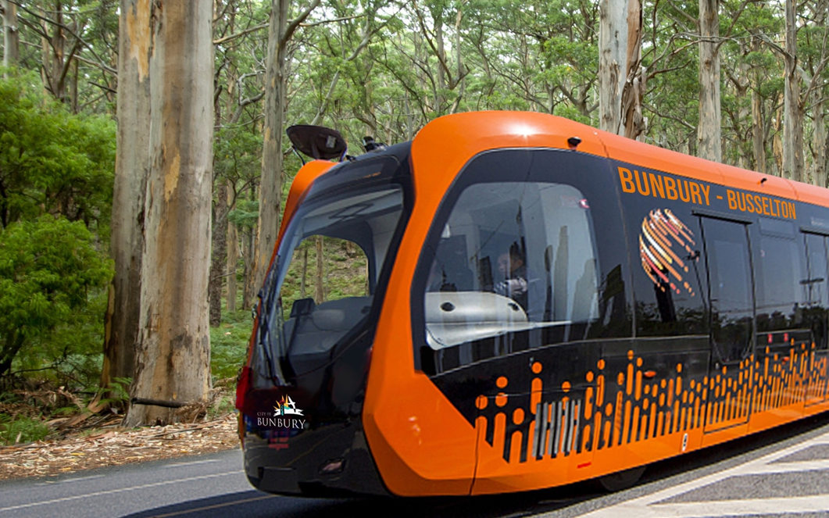
Figure 2 Iconic Tourist Trackless Tram. Source: Marie Verschuer

The obvious route for the fast train south is along the Forrest Highway and to the north along the Coastal Highway. They could be built using value capture where private developments pay for the fast connection to Perth that gives the land value to build on. These fast services need to be separated from freight.

High-Speed Rail is likely to begin between Melbourne and Sydney in the 2020’s. They will probably be based on zero cost to government using land value capture by building new country towns within an hour’s journey to big cities. Once this happens then it makes sense to see how a service to Brisbane, then Adelaide and on to Perth, can be done.

There will be less and less flying due to expensive renewable fuels regulated across the world and made by turning Hydrogen into green jet fuel. Solar-based electric high-speed rail will come into its own in Australia and become a major tourist attraction along with overnight services for business journeys from Perth to Melbourne/Sydney.

Short Term:
1. Complete the planning of the Fast Train to Bunbury and, based on clear benefits and costs that can be shared, commit to its building in the 2020’s.
2. Establish Trackless Tram links in the South West and in Perth that can enable tourists and visitors to have car-free holidays to the South West.

Long Term:
1. Conduct detailed assessments of how the same innovations brought to the Bunbury Link can be made to Geraldton, then Albany and Kalgoorlie.
2. Examine the potential for High-Speed Rail between Perth and Sydney providing an overnight service.

Mid-Tier Transit as a Connector – the Next Step
Trackless Trams have been on the agenda at CUSP for three years as a next step opportunity instead of using expensive and disruptive light rail. We are working on it with 5 local governments and state agencies in Perth, with Bunbury/Busselton in the south west, with local governments and state agencies in Townsville, Sunshine Coast, Liverpool (Sydney), Wyndham (Melbourne and two new private developers this year), and overseas with groups in Philadelphia, New York and Bulawayo in Zimbabwe. See

The Trackless Tram is a 21st century mid-tier transit technology tram with the ride quality of light rail but the ability to be quickly implemented as it has batteries on the roof instead of an overhead catenary and follows a white painted line through sensors that enable it to travel like a light rail. We will be doing a Trackless Tram trial in Perth with partners who want to see it certified before pursuing it for procurement.

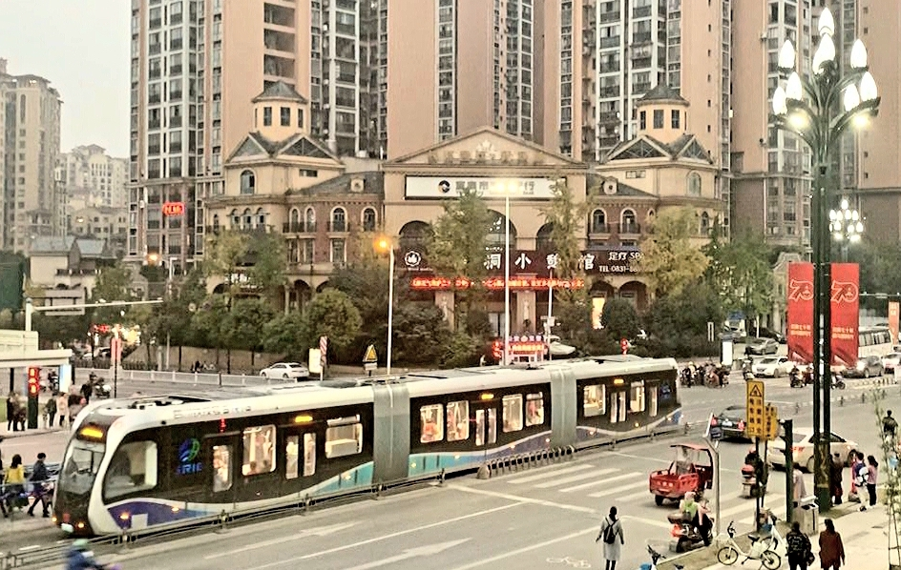
Figure 3 Trackless Tram in Yibin, China.

The City of Stirling have a $2m grant to do a Business Case on a Trackless Tram down Scarborough Beach Road and other local governments like Melville and Fremantle have been doing their own studies. The Federal Government are very supportive of this technology saying the following while delivering the funds for the City of Stirling:

"...Minister for Population, Cities and Urban Infrastructure Alan Tudge said the trackless tram technology had the potential to be expanded into public transport systems across the country.
“This is ground breaking technology that has the potential to be rolled out across our cities,” Tudge said. “Being a fraction of the cost of traditional rail solutions it could enable a massive expansion of public transport, it is very exciting.”
Trackless Trams need to be considered as part of the move to resolve a Movement and Place Strategy for main roads in Perth and other areas (like Bunbury), as the TT can be a way to improve public transport and to enable a site for urban density to be welcomed. We have begun to call these routes 21st century boulevards. This is a combination that can assist the consolidation of Perth without so much pressure on backyards for unpopular and dysfunctional infill. The TT can be manufactured here and will be an important step towards electromobility based on solar energy (see below).

Short Term:
1. Support a Trackless Tram Trial in Perth and create an industry around its local manufacture with local technology such as batteries.
2. Create a series of routes for Trackless Trams along Main Roads, especially those leading to MetroNet stations, as part of the Movement and Place Strategy which can enable new 21st century boulevards through public private partnerships with developers around station precincts. This should include the role of electromobility and micromobility in recharge strategies at station precincts.
3. Develop a DesignWA template for density around mid-tier transit station precincts along main roads that can also incorporate the need for electromobility recharge hubs.

Long Term:
1.Develop a network of green routes for Trackless Trams and dense station precincts with electromobility integrated into them to create a much-reduced need for car travel in Perth.

Westport and Fremantle – Rebuilding Kwinana and North Fremantle
Westport has emerged from the 2016 election’s major focus on the problems associated with Roe 8,9 and 10 which went well beyond the issues of the Beeliar wetlands. The reality of too many trucks going through the state’s historic port has been an issue for many years and the Roe 8, 9 and 10 just continued this way into the future without a solution. It is a common issue in modern cities where containers are not able to fit into their historic ports usually built within the mouth of a river to provide shelter for sailing ships. Fremantle needs a new future where some port functions remain as in the centre of Sydney and Melbourne but containers move to Westport (Kwinana).

The need for Westport to be built in Kwinana quickly is also driven by the need for a more industry-based port where land-backed facilities in the area can feed directly into a simple exercise for exports. This is increasingly how major cities in the Indian Ocean region are moving and WA has opportunities to improve our manufacturing capability by building a 21st century port. At the same time the North Fremantle area will have a chance to regenerate large areas of land once lost to container terminal operations and already being slowly reclaimed for residential, tourism and knowledge economy job places.

As outlined above in considering MetroNet into the future, the development of passenger rail services from Cockburn Central to Fremantle is an important missing link in the urban rail network and will lead to further regeneration of station precincts along that route and a much more connected southern corridor. This connection cannot be built until the container port moves south.

North Fremantle and South Fremantle/Cockburn are important areas that need greater visioning processes from local communities about how to create better transit and urban development opportunities. This can now be done because of the need to rebuild the Fremantle Traffic Bridge and the options that have been created are now suggesting a bigger story around the shifting of the port and regeneration of old port and freight-related areas.

The issues are confused by the need to resolve growing freight on rail, a much-needed shift that has eased the truck growth but not solved the issue within the Fremantle area. For the short term a new rail bridge is being proposed to take further increases in rail freight that can be built at the same time as replacing the old traffic bridge. However, this appears to make options for regenerating North Fremantle much more difficult and certainly to put off the need to shift the Container Port for over 20 years. The agencies responsible are unable to see the timescale for the shifting of the port due to the need to finalise Westport plans (now in the hands of state agencies with a budget of $100m). These issues have created a vacuum that is being filled by civil society visons and ethical perspectives on the longer-term value of their places of abode, recreation and work.

Many of these problems will disappear when the decision on the port happens and a timely departure is set in motion (I expect this in the next 12 months). We do not need to be left with too few options for cleaning up and regenerating North Fremantle into a new future urban area and for the regional corridor to its north. There has been no community-based regional plan for this area, not at any stage in the past 40 years as it was a functioning major port.

Short Term:
1. Complete the planning and assessment of Westport and given its clear benefits and costs that can be shared, commit immediately to commence its building.
2. Establish guidelines, governance and partnership processes to enable major land-based innovations featuring zero carbon exports to occur in Westport including Lithium Valley processing and exporting of Green Battery Minerals as well as Defence shipping.
3. Develop a vision for North Fremantle within a Regional Plan using the local community and stakeholders to ensure all the best options for urban regeneration are not lost due to short term infrastructure issues such as the bridge replacement.

Long Term:
1. Establish the world’s first Net Zero Port at Westport with all operations from transport, port operations and requirements from shipping.
2. Rebuild North Fremantle as well as the continuing development of Spearwood, Coogee and South Beach as rail-based regeneration, complete with Trackless Tram connections.

Regional Ports and Airports – the Hydrogen Connection
The next phase of regional development will be about Hydrogen. In the context of net zero emissions new visions are beginning to form, ones in which hydrogen has a central role in decarbonizing industry. The geographical distribution of the potential for “green” hydrogen from solar and wind driven electrolysis and “blue” hydrogen from methane with CCS (difficult and expensive) will reshape where heavy industry is located, how value chains are organized, and what gets transported in international shipping.
Regions with bountiful solar and wind are likely to become exporters of hydrogen or hydrogen carriers such as methanol and ammonia, as well as home to the production of iron and steel, polyethylene, and other energy intensive basic materials. This in turn may generate new trade patterns and need for bulk transport. Western Australia has all of these.
In most applications, renewables-based electrification has emerged as the most energy efficient, and cost-effective way to strip emissions from the economy. Yet there are some industries where electrification will remain challenging. It’s here renewable hydrogen — produced from wind and solar energy — will be most important. These industries include steel, cement, aluminium, battery minerals, shipping and aviation.
A renewable hydrogen export market may also emerge in the long-term, though WA’s Hydrogen Strategy is aiming for a quicker transition and indeed being a global leader as suggested by Ross Garnaut in his book Superpower. There seems to be tri-partisan support for this policy.
If produced at regional shipping ports close to aluminium, steel or cement plants, this will provide further opportunities to expand renewable hydrogen use including minerals processing, while creating new jobs. Oakajee seems an ideal place to begin such work.
Hydrogen is often discussed at the same time as electromobility (see section below on EV’s) but Hydrogen in reality will not play a major role in road transport as it requires significantly more solar energy and extra cost. There are several extra steps involved in using Hydrogen that go beyond the solar electricity that battery electric vehicles can take easily from the grid. Hydrogen must be split from water and be stored and distributed where there is no grid at present. Hydrogen vehicles will always consume two to four times more energy than battery electric vehicles. This is simply due to the laws of physics, and cannot be resolved by technological improvements in other than marginal ways.
Electric vehicles already have longer driving range and continuously expanding charging infrastructure, including ultra-fast chargers. The US Department of Energy does not expect hydrogen semi-trailers to be competitive with diesel until around 2050, mainly due to the high cost and low durability of hydrogen fuel cells. This will not help Net Zero by 2050.
However Hydrogen can be the only solution to scale up the industry to cope with the Net Zero market for all minerals and processed goods. WA should focus on this in regional development.
As Hydrogen production scales up and costs fall, excess Hydrogen would be available at ports for fuelling ships and for export — either directly or through a Hydrogen derivative like ammonia. Hydrogen could also be used to make carbon-neutral synthetic fuel for planes. This will be important for WA as the distances in our state will always need aviation for scattered regional areas that are critical economically, as well as the tourism industry. Short distance small planes could be electric but mostly we will need to make jet fuel as this is one place in the world it will be relatively cheap due to the space needed to make the Hydrogen. Thus Hydrogen needs to be on the agenda for WA as a source material for creating green jet fuel.
Short Term:
1. Complete the Renewable Hydrogen Strategy for Regional Development with Net Zero financing to help direct rapid delivery for major exports of green minerals and green Hydrogen.
2. Establish demonstration Hydrogen projects at major regional ports, especially Bunbury, Oakagee, Exmouth, Kalgoorlie/Esperance, Dampier and Broome in partnership with major industries.
3. Postpone any urban and long-haul Hydrogen fuel cell truck demonstrations until the technology becomes competitive with solar-based electromobility.
4. Ensure that every new gas development is about Blue Hydrogen or else it is not allowed.

Long Term:
1. Develop a partnership program to create a globally competitive synthetic jet fuel from Solar-based Hydrogen using the local companies that are establishing demonstrations of Hydrogen in mining and industrial processing.
2. Establish a long-term framework for exporting Green Hydrogen, Green Steel, Green Aluminium, Green Rare Earths and Green Battery Minerals and how they can be shipped using Carbon-free fuelled railways, trucking and shipping.

Electromobility and Micromobility – The End of Oil
The biggest transport market over the next few decades will be for electric light duty vehicles. Over 50% of Australians are saying that their next vehicle will be electric and globally it is expected that EV’s will be cheaper than Internal Combustion Engine vehicles by 2023.

One of the important benefits in EV’s in coming decades is that they can provide electricity grid services in a two-way flow to the network. 100,000 electric vehicles can provide 500MW of standby power whenever the grid needs to tap an instantaneous source of power as the grid is short of supply or an instantaneous source of storage capacity if the grid is producing too much power. It just needs an internet of electricity to manage these potentials as soon as any electric vehicle is plugged into the network.

Australia is very well placed to demonstrate how EV’s can integrate into the power grid in new and important ways as the renewables revolution rolls out across the power systems of the world. We are leading the world in demonstrating distributed power systems from roof top solar and the early days of the Internet of Energy. What we don’t yet do is work the batteries of EV’s into this emerging integrated system.

Electromobility is of course much more than just electric cars and trucks. There is a big market for electric scooters, skateboards and bikes emerging, especially since Covid where significant demand for relocalization of services and transport has happened around the world. This needs to be facilitated through more active transport funding.

The next phase for governments is to electrify not just their car fleet but also their bus fleet. ACT has already taken big steps in this direction of having a Net Zero power and transport system by 2040. Trackless Trams are showing what batteries on buses can do to transform the ride quality and improve station environments. As all these take-off in the local and global market in the 2020’s there will be a need for government to provide some incentives and reductions in regulatory barriers.

Short Term:
1. Immediate guidance should be given to all government fleets and private fleets suggesting they create a plan for how they will switch to electric vehicles. Incentives should be provided through grants to help build EV charging stations for fleets (perhaps through a reverse auction on bids for the most EV’s). Targets should be set of 25% within 5 years minimum for all eligible vehicles (not home garaged) rising to 50% within 3 years.
2. The PTA should begin a process to prioritise the electrification of the bus fleet including the purchase of fully electric Trackless Trams to meet the target of zero emissions transit by 2040.
3. Active transport should be given a boost in funding and spatial allocations in the road system in response to the need for more local micromobility systems.
4. Electric micromobility priority and pedestrian priority will need to be separated in all new demonstrations of transit activated corridors and in any upgrades of cycleways.

Long Term:
1. Find new ways of enabling registration and fuel taxes to be replaced with both a road/parking space levy and a road user-pays levy on electric vehicles. These need to be discussed and formalised in the 2020’s.
2. Develop solutions for standardization of EV recharge plugs and service pumps, recycling of batteries and the potential for niche vehicle manufacturing opportunities in Western Australia.
2. Resolve how electromobility and urban development will be used to enable grid stabilization and facilitate the knowledge to be spread around the world creating local jobs in the businesses.
3. Transit Activated Corridor’s need to be created and integrated into a full Movement and Place plan that provides connectivity and accessibility at world best practice by transit and micromobility and these should be fully recognised in the Metropolitan Regional Plan.

Net Zero Urban Development
Net Zero is the new normal post-Covid. Net Zero or as it was called before Carbon Neutral, has a history of being defined for businesses and local governments seeking to be carbon neutral. These carbon neutral systems have been set up through Federal government guidelines (agency is now called Climate Active) and through non-government associations (such as C40, ICLEI, Greening Australia) seeking to enhance activity in the Net Zero Carbon arena. The common thread to these requirements/recommendations is that carbon neutral or net zero involves combining activities that are within the sphere of influence of the organization. They involve the consumption of fossil fuels or production of greenhouse gas emissions then offsetting those activities they cant influence. Thus the three levels of activity for achieving Net Zero are:
- Reduce consumption of fossil fuels and reduce land clearing;
- Add renewable energy or procured green power; and
- Commit to offsets by planting or managing vegetation that sequesters in legally accredited programs. Local Natural Resource Management groups can provide these carbon offsets to companies wanting to be Net Zero and help regenerate large areas of agricultural land (see further below).

The accounting needs to show that the net result for GHG is zero. Increasingly this is seen to need more factors added such as embedded energy in materials and products consumed, transport of materials and products to where they are consumed, and other life cycle GHG from any key activity involving the organization, city or any collection of humanity in whatever boundary is being considered. So there is a growing need for Net Zero requirements and regulations to be clarified.

Net Zero has become much more part of the political agenda because it is now required as part of the Paris Agreement and almost completely now by global finance institutions. This approach has been adopted by most major companies in WA and now needs to be taken on by the whole metropolitan region.

Large cities cannot be managed at the whole of region scale for Net Zero outcomes without enabling each local area, business, community and household within the city to do their part, which is within their capacity, to achieve Net Zero outcomes. Increasingly this is being seen as having different functions and potentials depending on the different urban fabric that is being managed. For example the variations across Perth in transport and buildings are considerably different depending on their urban fabrics. Central and inner areas use ten times less fuel than outer and peri-urban areas.

Accounting for Net Zero Carbon therefore needs to be applied at a whole urban region scale and at each geographical part of the city, as well as by contributing sectors, companies, communities and even households. Such accounting needs to be done in a way that enables each different geographical entity or urban fabric to approach their Net Zero Carbon challenge in a way that builds on their local needs and potential to respond. This has started in Perth with demonstrations by Development WA at WGV (White Gum Valley) and East Village (Fremantle).

The IPCC agenda that pushes cities towards achieving Net Zero Carbon will also require some cities to actually do better than Net Zero as the world needs to begin to first of all share in the extent of responsibility for reducing carbon emissions by producing more renewable energy than it consumes. This is what global and national conferences on sharing the responsibilities for climate emissions, have been about for many decades.

But there will be a new and more dramatic responsibility that is likely to involve cities in the future as climate change impacts continue to grow and the IPCC has foreshadowed the need to go beyond Net Zero and begin reducing the concentration of CO₂ in the atmosphere back to manageable levels as global carrying capacities are already being exceeded. This will require cities, or at least some cities, to regenerate the atmosphere by extracting more and more CO₂ from the atmosphere. The main mechanism for this is likely to be regenerating the settlement bioregion’s catchment with plantings that sequester carbon and build up soil carbon. Such planting has been a part of Perth and many major companies in WA who are doing offsets in the southwest through organizations like Greening Australia and Gondwanalink that is building a regenerated area of conservation for over 1000 km from the coastal Karri through to the Western Woodlands. This has had global interest with others now trying to copy such innovation.

This agenda needs to be considered by cities as they prepare for their future commitments and how they can contribute environmentally and socially whilst simultaneously gaining economically from the opportunities created in such leadership.

This should be considered a transition from Exploitive Cities – Exporting Carbon to the Atmosphere; to Sustainable Cities – Neutralising Carbon, to Regenerative Cities
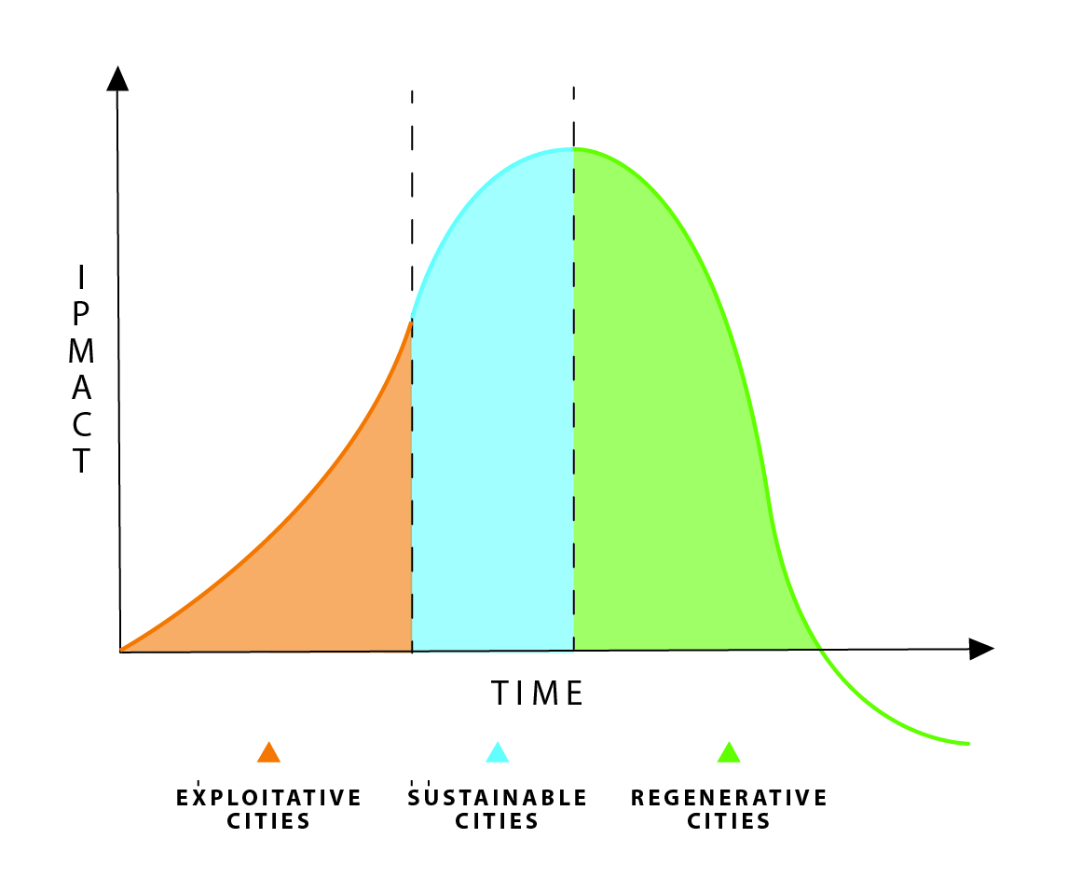
Figure 4 The transition from exploitive to sustainable to regenerative cities.

Short Term:
1. Develop new DesignWA Guidelines for how we can create Net Zero Urban Development in City Centres, Inner areas, Middle Suburbs, Outer Areas, Peri-Urban and Regional Settlements.
2. Demonstrations need to be continued by Development WA and must now include all Housing Authority developments.
3. Create a Net Zero Urban Strategy for WA linking strategies for climate, distributed energy, electric vehicles, renewable energy and biodiversity conservation.
4. Enable NRM groups to access the Net Zero market for carbon offsets as part of the multi-benefit process of regenerating regions in WA.

Long Term:
1. Net Zero needs to be mainstreamed into all strategic and statutory planning documents guiding urban development across the state.

Michael Kane (2021) Explaining the secret to knowledge-based megacities, International Journal of Knowledge Based Development, (in submission)

